*Florida International University*

*School of Computing and Information Sciences*

Software Engineering Focus

Feature Document

User Story ID <671 USDA Endpoint>

**Name: Frank Hernandez**

**Team Member(s): Bertha M Perez**

**Frank Hernandez**

**Project: Snackability 1.0**

**Product Owner(s)**: Dr. Cristina Palacios

**Mentor(s)**: Dr. Cristina Palacios

**Instructor**: Masoud Sadjadi

**User Story Name:** 671 USDA Endpoint

### **Description:**

* As an administrator I would like to see what kind of information I can get and send to the USDA api.

### **Acceptance Criteria:**

1. postman script targeting multiple USDA endpoints
2. a visual display of the JSON.

### **Related Tasks:**

1. Get API for USDA database

The Product Owner Mrs Cristina Palacios request an API key for the project: *5iTjOxsZPmUo2U4p5SBQi1LL603l6x5b0jYsc4sO*

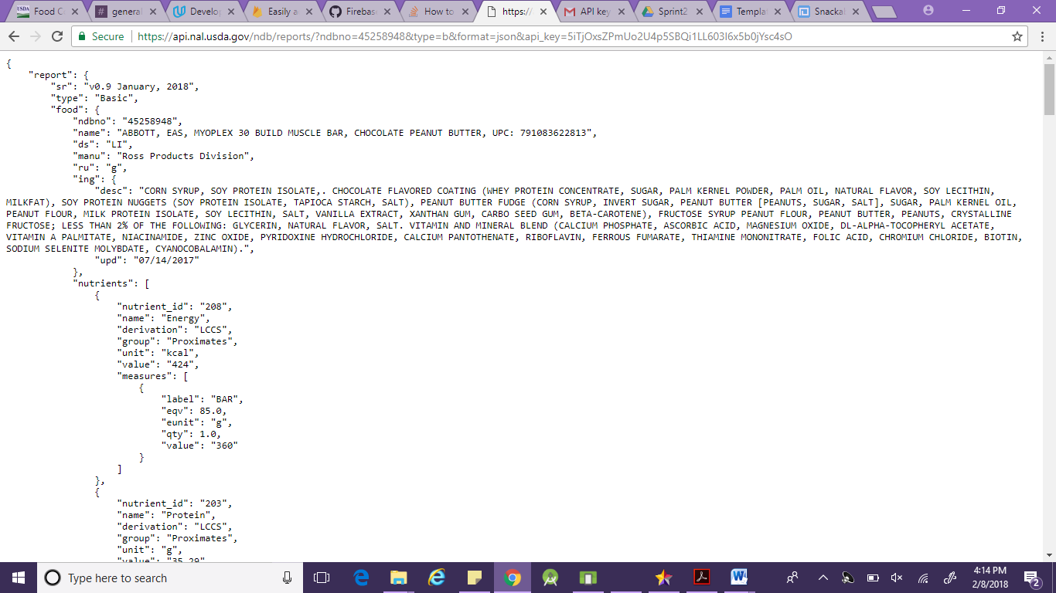

The USDA API provides two kinds of reports: [**Food Reports**](https://ndb.nal.usda.gov/ndb/doc/apilist/API-FOOD-REPORT.md) which list nutrient values for a specified food and [**Nutrient Reports**](https://ndb.nal.usda.gov/ndb/doc/apilist/API-NUTRIENT-REPORT.md) which provide lists of foods and their nutrient values for a specified set of nutrients.

We can find a lot of information, we are going to list what is relevant for our app

* List of ingredients (We are going to use the main ingredient listed as the first ingredient)
* Nutrients:
* Energy (kcal)
* Sodium, Na(mg)
* Total Lipid(fat) (g)
* Fatty acids, total saturated (g)
* Fatty acids, total trans (g)
* Sugars